CONTENTS
CHAPTERS PAGE NO
1 INTRODUCTION
1.1 INTRODUCTION 3
1.1.1 SCOPE OF THE PROJECT 3
1.1.2 OVERVIEW OF THE PROJECT 3
1.1.3 EXISTING SYSTEM 3
1.1.4 LIMITATIONS 3
1.1.5 PROPOSED SYSTEM 4
1.1.6 FEATURES 4
1.1.7 ADVANTAGES OF PROPOSED SYSTEM 4
1.2 OBJECTIVE OF THE PROJECT 4
1.3 ORGANISATION OF THE PROJECT 4
2 SYSTEM SPECIFICATIONS
2.1 SOFTWARE SPECIFICATIONS 5
2.2 HARDWARE SPECIFICATIONS 5
2.3 REQUIRED PACKAGES 5
3 BASIC INFORMATION
3.1 DATA ANALYSIS 6
3.2 WHY WE USE DATA ANALYSIS 6
3.3 PANDAS 7
3.4 NUMPY 7
3.5 MATPLOTLIB 8
3.6 SEABORN 8

4 IMPLEMENTATION
4.1 IMPORT LIBRARIES AND READ THE DATA 9
4.2 CLEANING THE DATA 10
4.3 TRANSFORMING THE DATA 11
4.4 VISUALIZING THE DATA 13
5 CONCLUSION 14
6 FUTURE SCOPE 14
7 IMAGES 15
8 REFERENCES 26

INTRODUCTION
1.1 INTRODUCTION:
This analytics project is very component to understand the use of data analytics. Through projects like this many companies can understand various complex operations. Uber Data Analysis project enables us to understand the complex data visualization of this huge organization . It is developed with the help of Python Programmming language.
SCOPE OF THE PROJECT:
The main objective of Uber Data Analysis is to find the days on which each basement has more trips and the days on which each basement has more no of active vehicles. In this project we will be performing analysis on Uber dataset using Python.
OVERVIEW OF THE PROJECT:
The project can be used to perform data visualization on the uber data. The data comprises one complete year of trips, with a total of about thousands of entries. This much data needs to be represented beautifully in order to analyze the rides so that further improvements can be made accordingly. If there is more information that containing base number, date, active vehicles and trips, the data not containing any of the above that can be removed or necessary changes can also be done for future endeavors.
EXISTING SYSTEM:
- Customers are often dissatisfied with traditional cab companies because of their high prices and long waiting time and hence can exploit new and big markets in countries like India. Can tap growing markets in suburban areas where taxi services are not available.
- We can predict the future growth of our business by analyzing our past data.
LIMITATIONS:
- Based on past data only, we can take future decisions.
- Sufficient data must be required to predict right decisions in future projects.
- CSV data file should be required to analyze the data

PROPOSED SYSTEM:
- We proposed that we will find the days on which each basement has more trips.
- Customers are often dissatisfied with traditional cab companies because of their high prices and long waiting time and hence can exploit new and big markets in countries like India.
- Find the days on which each basement has more number of active vehicles.
- Estimated Time of Arrival can be reduced with rise in the number of Uber drivers which in turn will make Uber more liked by the customers and hence, the startup will get more revenue and drivers will also be profited.
FEATURES:
- Visualization may help us to understand clearly, about uber data.
- Writing program i.e source code is easy.
ADVANTAGES OF PROPSED SYSTEM:
- Estimated Time of Arrival can be reduced with rise in the number of Uber drivers which in turn will make Uber more liked by the customers and hence, the startup will get more revenue and drivers will also be profited.
- Convenient system for the drivers.
- Taking decisions should be easy by using data analysis.
1.2 OBJECTIVE OF THE PROJECT:
- The motive is to increase market share and achieve economics of scale and at the time providing customer satisfaction.
- Reducing the estimated time of arrival.
- UBER wants to be the first choice for every customer.
1.3 ORGANISATION OF THE REPORT:
Report includes the stepwise implementation of the Data Analysis process and it describes the overview of how effectively the project can be implemented and makes the viewer of the report to get an overview of the project.

2.SYSTEM SPECIFICATIONS
2.1 SOFTWARE SPECIFICATIONS
- Operating System : Windows
- Programming Language : Python
2.2 HARDWARE SPECIFICATIONS
- RAM : 2GB
2.3 REQUIRED PACKAGES
It requires the following packages:
- Numpy (version: 1.11.2)
- Pandas (version: 0.19.2)
- Matplotlib (version: 1.5.3)
- Seaborn (version: 0.6.0)

3 BASIC INFORMATION

DATA ANALYSIS:
The process of cleaning, transforming, manipulating data into useful information that is Data analysis. When we take a particular decision based on previous data that is data analysis. We can make future decisions using data analysis.
WHY WE USE DATA ANALYSIS:
All the business has lots of data. To grow business, sometimes data analysis required. By analyzing data we get important topics on which work out and make our plan for the future through which made perfect future decisions. Most of the businesses going online where the data generate increases day by day. To grow business with this competitive environment data analysis is necessary.

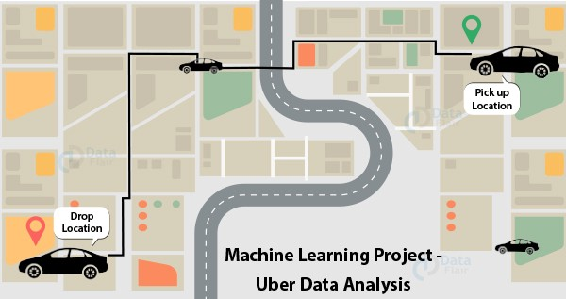
Fig.3.1-Uber Data Analysis
The project can be used to perform data visualization on the uber data. The data comprises one complete year of trips, with a total of about thousands of entries. This much data needs to be represented beautifully in order to analyze the rides so that further improvements can be made accordingly.
- PANDAS
Pandas is one of the tools in Machine Learning which is used for data cleaning and analysis. It has features which are used for exploring, cleaning, transforming and visualizing from data.Pandas is an open-source python package built on top of Numpy developed by Wes McKinney. It is used as one of the most important data cleaning and analysis tool. It provides fast, flexible, and expressive data structures. Pandas is derived from the term “Panel-data-s” an econometrics term for data sets include observations over multiple time periods for the same individuals.
- NUMPY
NumPy library is an important foundational tool for studying Machine Learning. Many of its functions are very useful for performing any mathematical or scientific calculation. As it is known that mathematics is the foundation of machine learning, most of the mathematical tasks can be performed using NumPy. NumPy stands
for ‘Numerical Python’. It is an open-source Python library used to perform various mathematical and scientific tasks. It contains multi-dimensional arrays and matrices,
along with many high-level mathematical functions that operate on these arrays and matrices

- MATPLOTLIB
Matplotlib is one of the most popular and oldest plotting libraries in Python which is used in Machine Learning. In Machine learning, it helps to understand the huge amount of data through different visualisations. Matplotlib is an open-source plotting library in Python introduced in the year 2003. It is a very comprehensive library and designed in such a way that most of the functions for plotting in MATLAB can be used in Python.It consists of several plots like the Line Plot, Bar Plot, Scatter Plot, Histogram e.t.c through which we can visualise various types of data.
- SEABORN
Seaborn is a library for making statistical graphics in Python. It builds on top of matplotlib and integrates closely with pandas data structures.Seaborn helps you explore and understand your data. Its plotting functions operate on dataframes and arrays containing whole datasets and internally perform the necessary semantic mapping and statistical aggregation to produce informative plots. Its dataset-oriented, declarative API lets you focus on what the different elements of your plots mean, rather than on the details of how to draw them.

IMPLEMENTATION
Here, we perform a data analysis task in four steps:
- 1) Importing Libraries and read the data
- 2) Cleaning the data
- 3) Transforming the data
- 4) Visualizing the data

IMPORTING LIBRARIES AND READ THE DATA:
import pandas as pd
import numpy as np
import datetime
import matplotlib
import matplotlib.pyplot as plt
import seaborn as sns
matplotlib.style.use('ggplot')
import calendar

data=pd.read_csv('uberdata.csv')
data.head()

CLEANING THE DATA
data.tail()
data=data[:-1]
data.isnull().sum()
sns.heatmap(data.isnull(),yticklabels=False,cmap="viridis")

data=data.dropna()
sns.heatmap(data.isnull(),yticklabels=False,cmap="viridis")

TRANSFORMING THE DATA:
data['START_DATE*'] = pd.to_datetime(data['START_DATE*'], format="%m/%d/%Y %H:%M")
data['END_DATE*'] = pd.to_datetime(data['END_DATE*'], format="%m/%d/%Y %H:%M")
data.head(25)
hour=[]
day=[]
dayofweek=[]
month=[]
weekday=[]
for x in data['START_DATE*']:
hour.append(x.hour)
day.append(x.day)
dayofweek.append(x.dayofweek)
month.append(x.month)
weekday.append(calendar.day_name[dayofweek[-1]])
data['HOUR']=hour
data['DAY']=day
data['DAY_OF_WEEK']=dayofweek
data['MONTH']=month
data['WEEKDAY']=weekday
time=[]
data['TRAVELLING_TIME']=data['END_DATE*']-data['START_DATE*']
for i in data['TRAVELLING_TIME']:

time.append(i.seconds/60)
data['TRAVELLING_TIME']=time
data.head()
data['TRAVELLING_TIME']=data['TRAVELLING_TIME']/60
data['SPEED']=data['MILES*']/data['TRAVELLING_TIME']
data.head()
price=[]
for i in data['MILES*']:
if float(i)<=50:
price.append(float(i)*2)
elif (float(i)>50) and (float(i)<=100):
price.append(float(i)*(1.75))
elif (float(i)>100) and (float(i)<250):
price.append(float(i)*(1.6))
elif (float(i)>250) and (float(i)<=500):
price.append(float(i)*(1.5))
else:
price.append(float(i)*(1.4))
data['PRICE*']=price
data.head()

VISUALIZING THE DATA:
sns.countplot(x='CATEGORY*',data=data)
data['MILES*'].plot.hist()
data['PURPOSE*'].value_counts().plot(kind='bar',figsize=(10,5),color='blue')
data['HOUR'].value_counts().plot(kind='bar',figsize=(10,5),color='green')
data['WEEKDAY'].value_counts().plot(kind='bar',color='green')
data['DAY'].value_counts().plot(kind='bar',figsize=(15,5),color='green')
data['MONTH'].value_counts().plot(kind='bar',figsize=(10,5),color='green')
data['START*'].value_counts().plot(kind='bar',figsize=(25,5),color='red')
data.groupby('PURPOSE*').mean().plot(kind='bar',figsize=(15,5))
data['PRICE*'].value_counts().plot(kind='bar',figsize=(20,5),color='green')

CONCLUSION:
The project can be used to be done data analytics using uber data. By doing that we can predict or take any future decisions in any project. Analysing the data is very easy and any one can understand clearly. We can statisfy the customer needs also.
FUTURE SCOPE
In Future we can send notifications about our rides, safety or any offers during festive seasons to our customers to increase number of rides. We can add any new feature also by using data analysis.

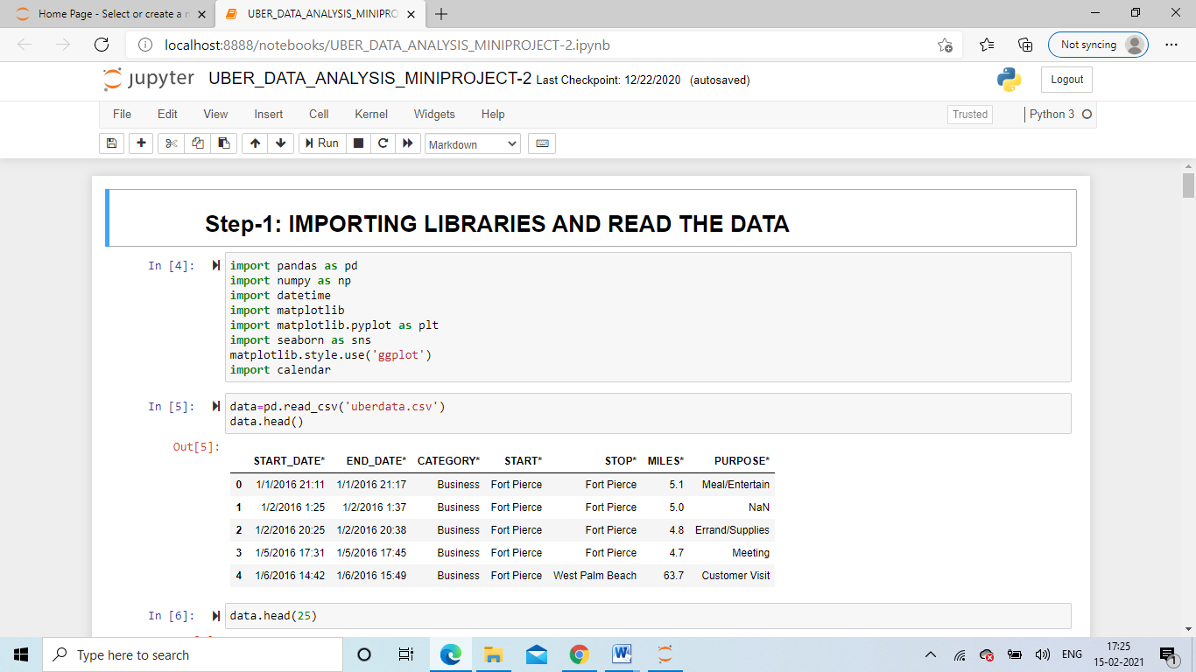
Fig.7.1-Importing libraries & Fig.7.2-Retrive first five rows
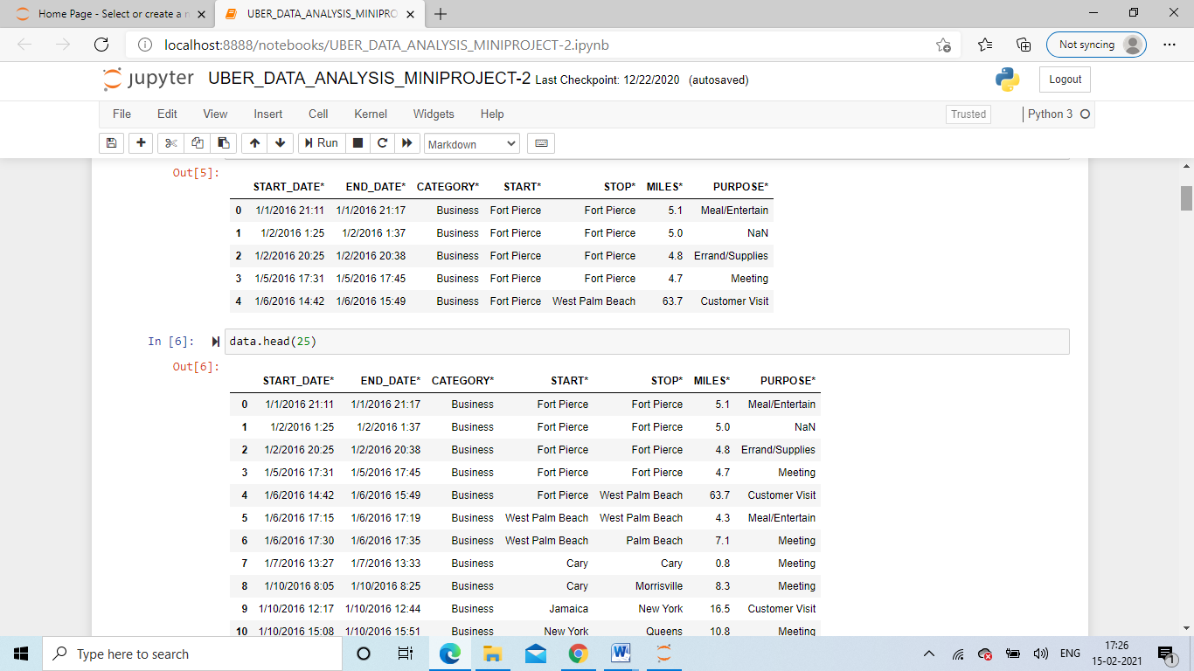

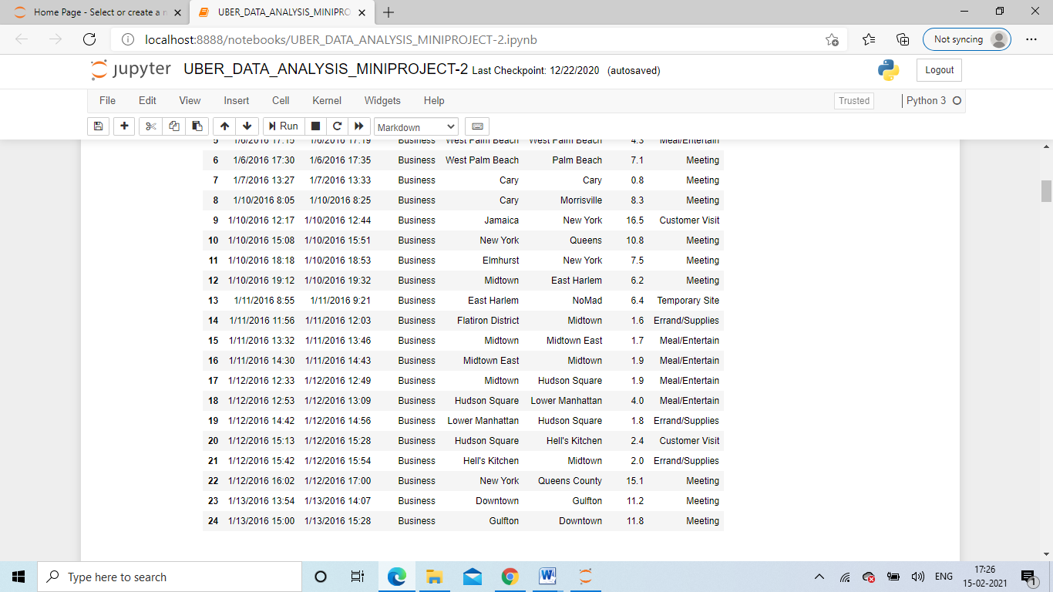
Fig.7.3-Retrive first 25 rows & Fig.7.4-Cleaning the data
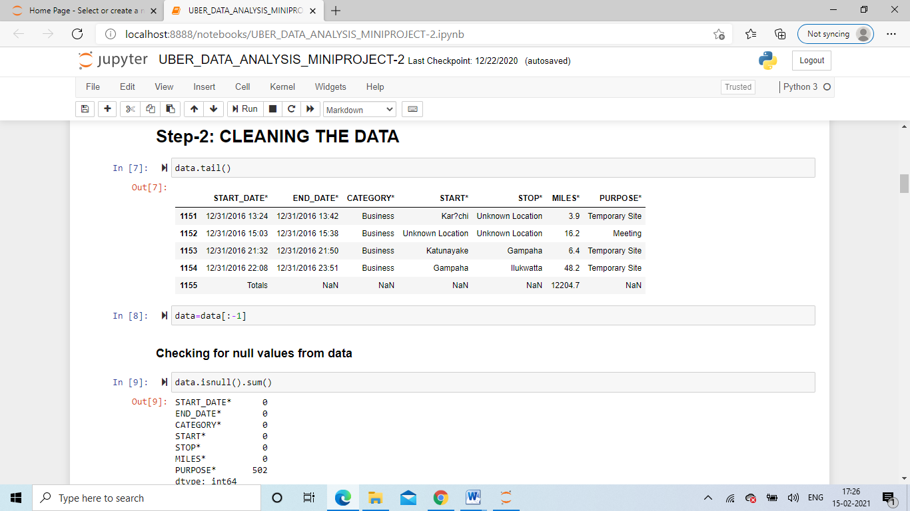

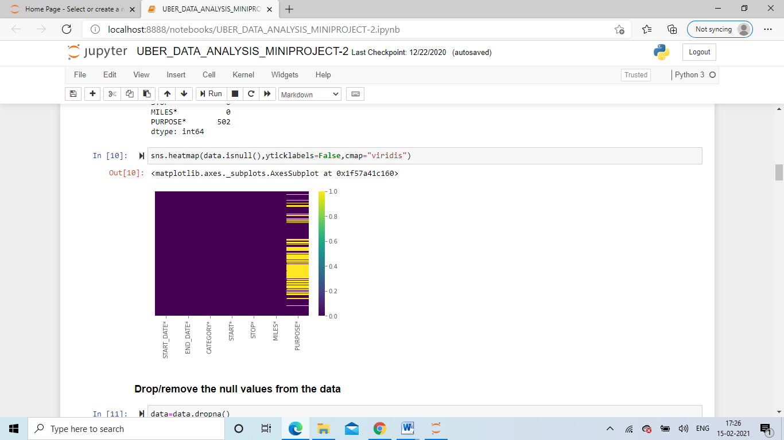
Fig.7.5 & Fig.7.6 commands for cleaning data Normally & Visually
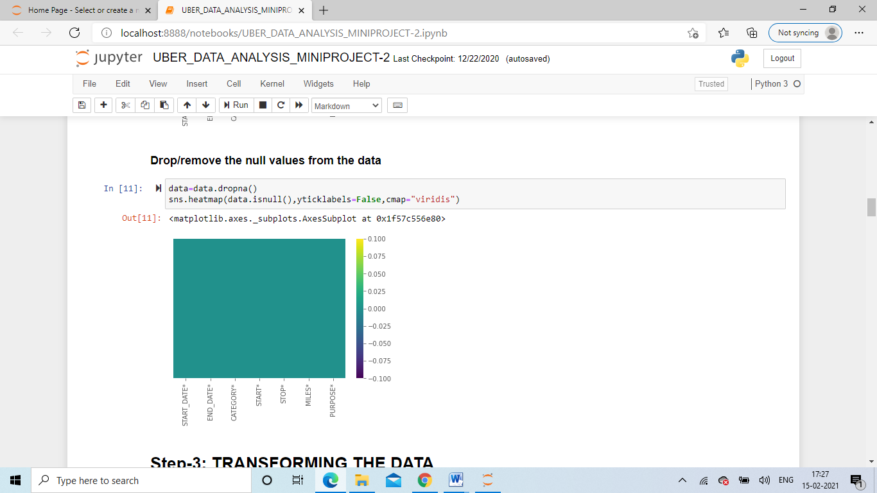
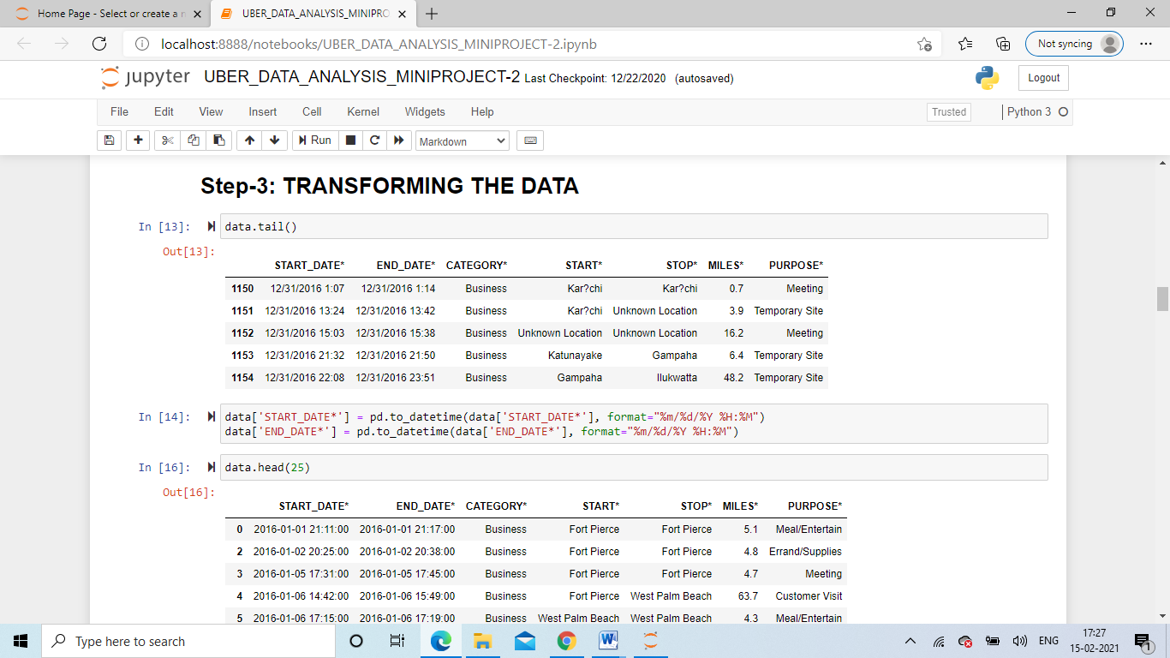
Fig.7.7 & Fig.7.8 Transforming the data
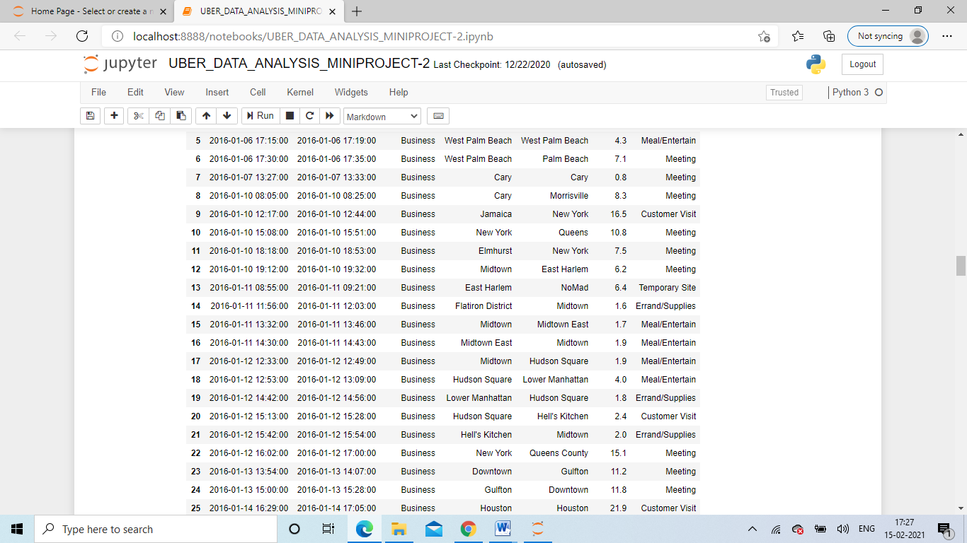

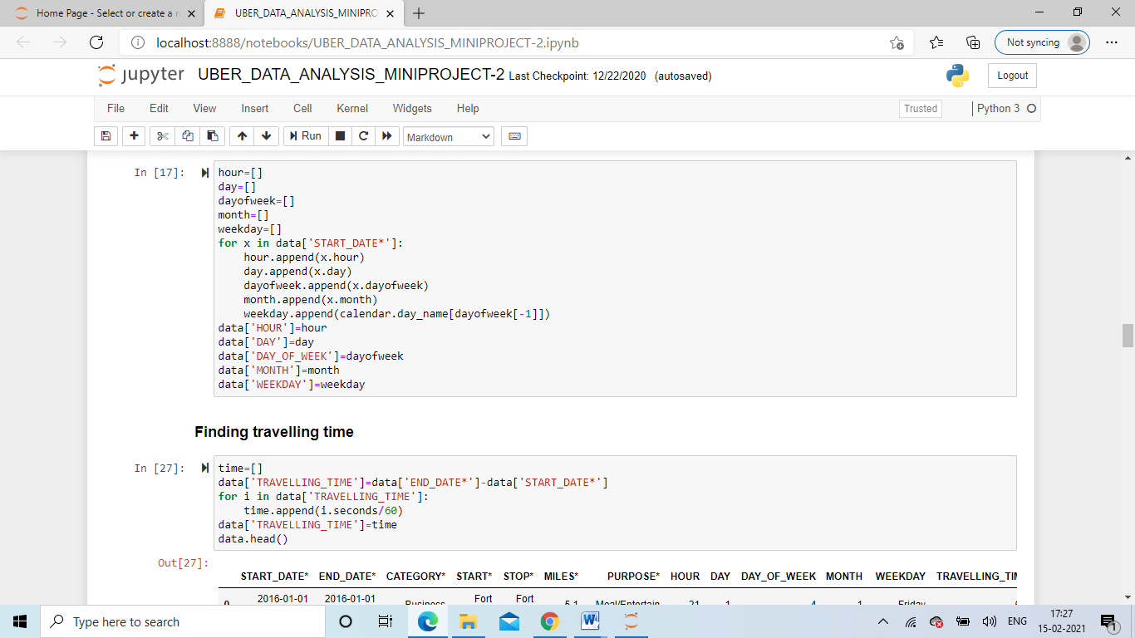
Fig.7.9 & Fig.7.10 Adding Columns for Uber data table
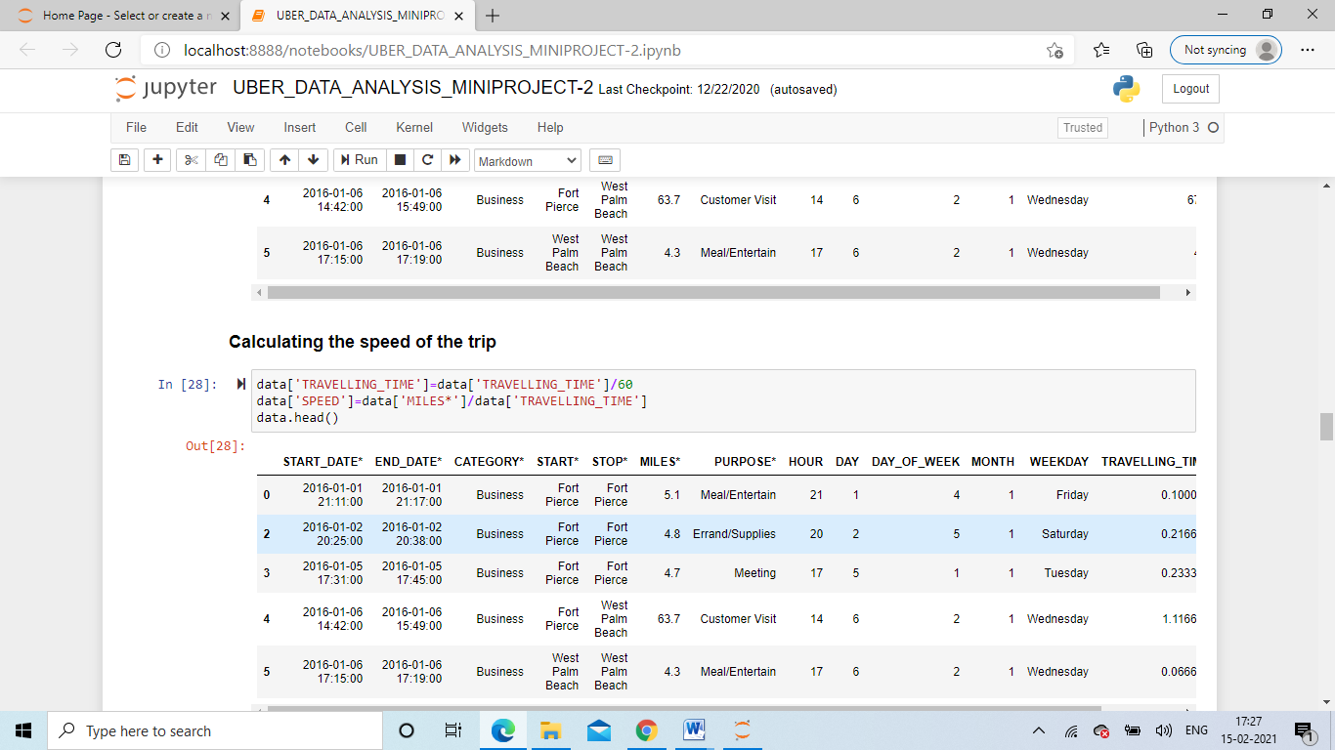
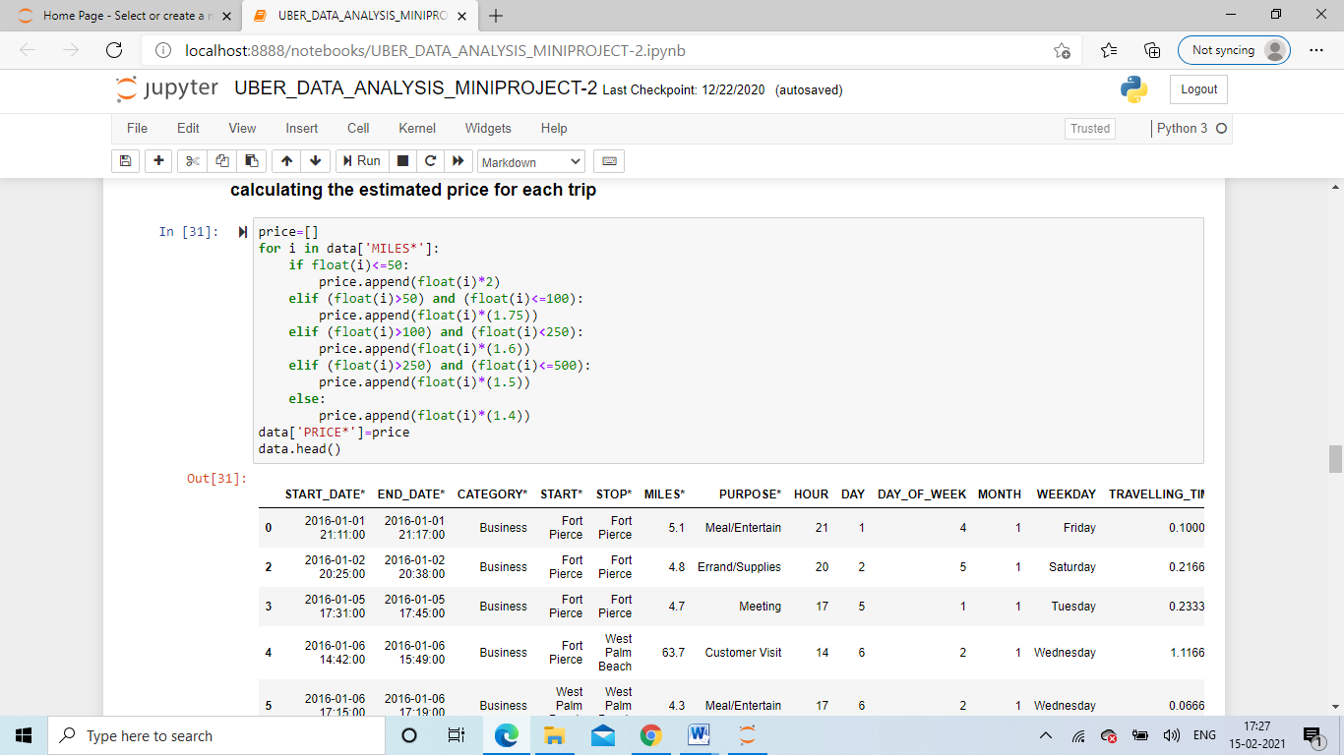
Fig.7.11 Price Column & Fig.7.12 Visualize the data
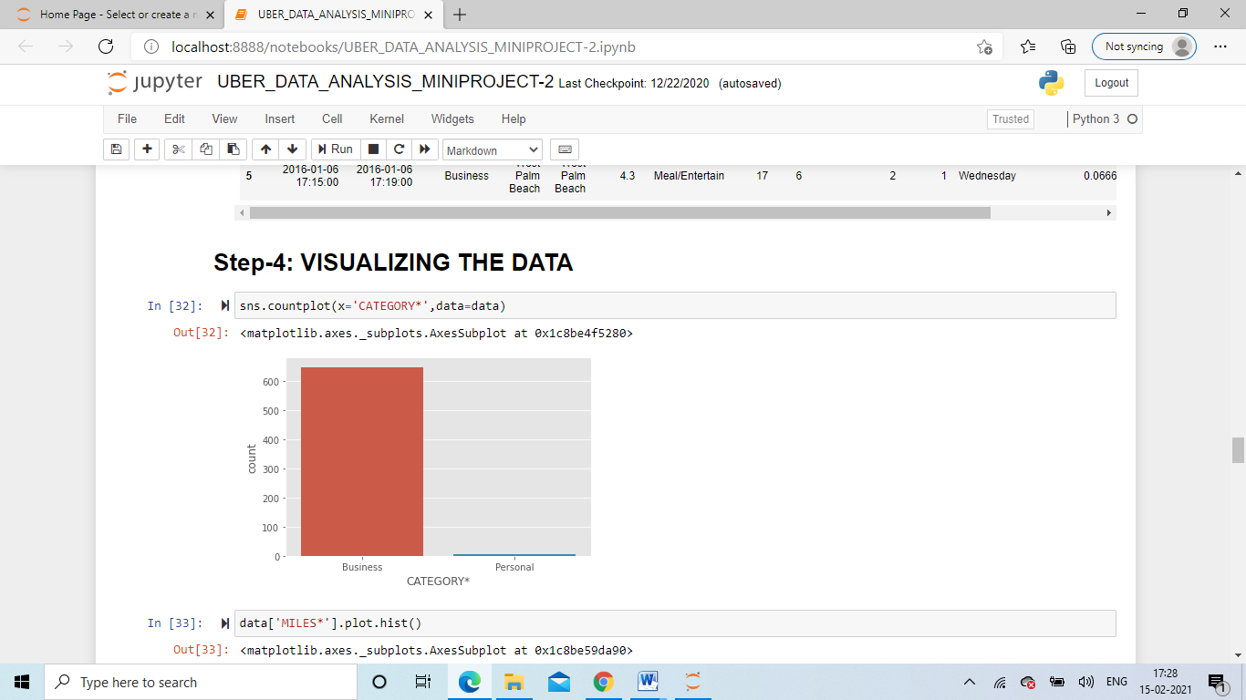
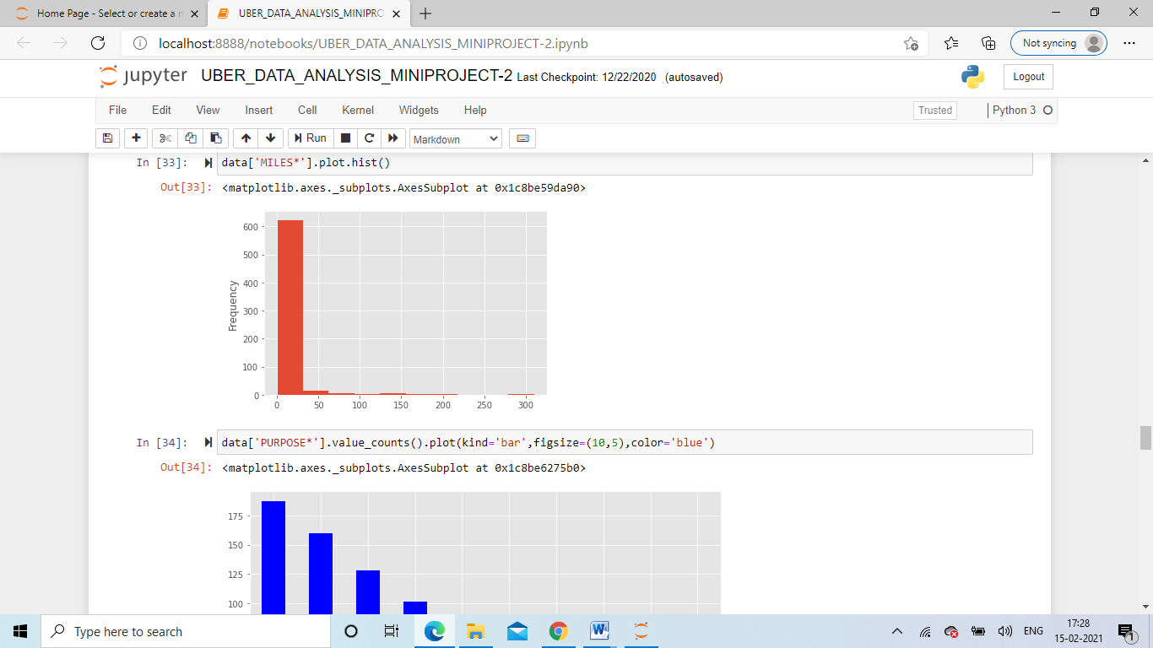
Fig.7.13 & Fig.7.14 Miles & Trips per hour analysis
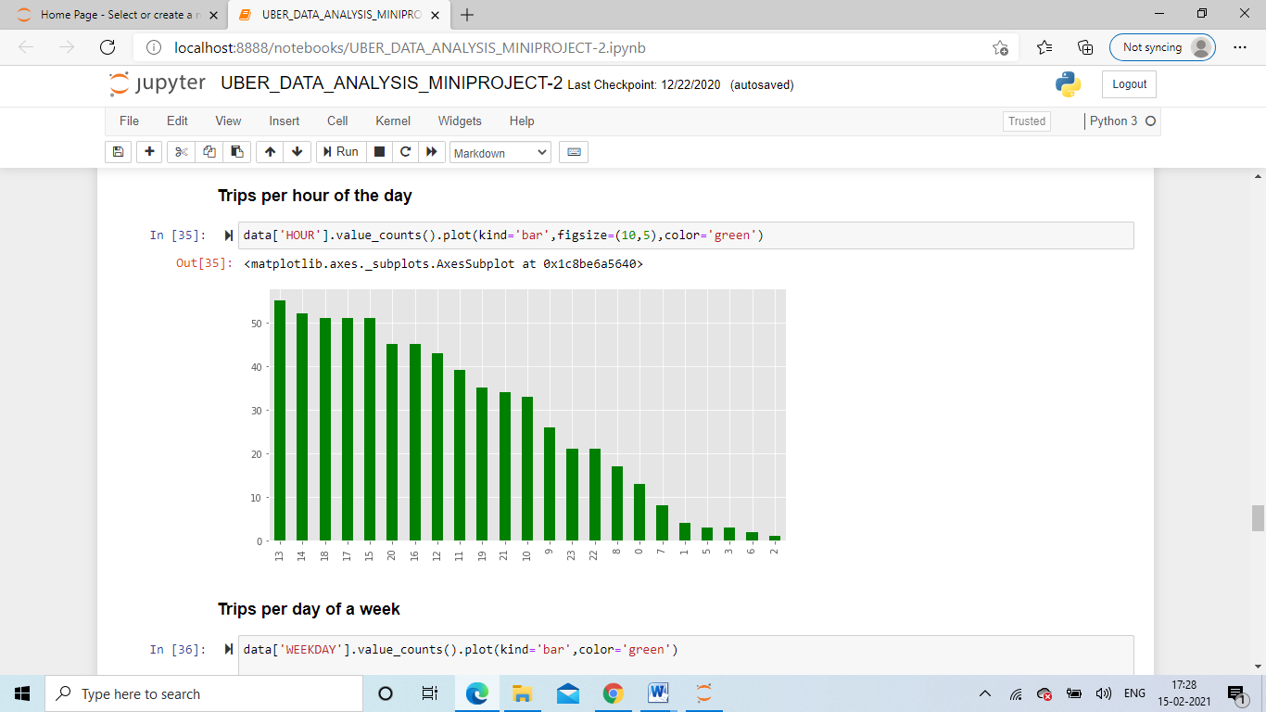
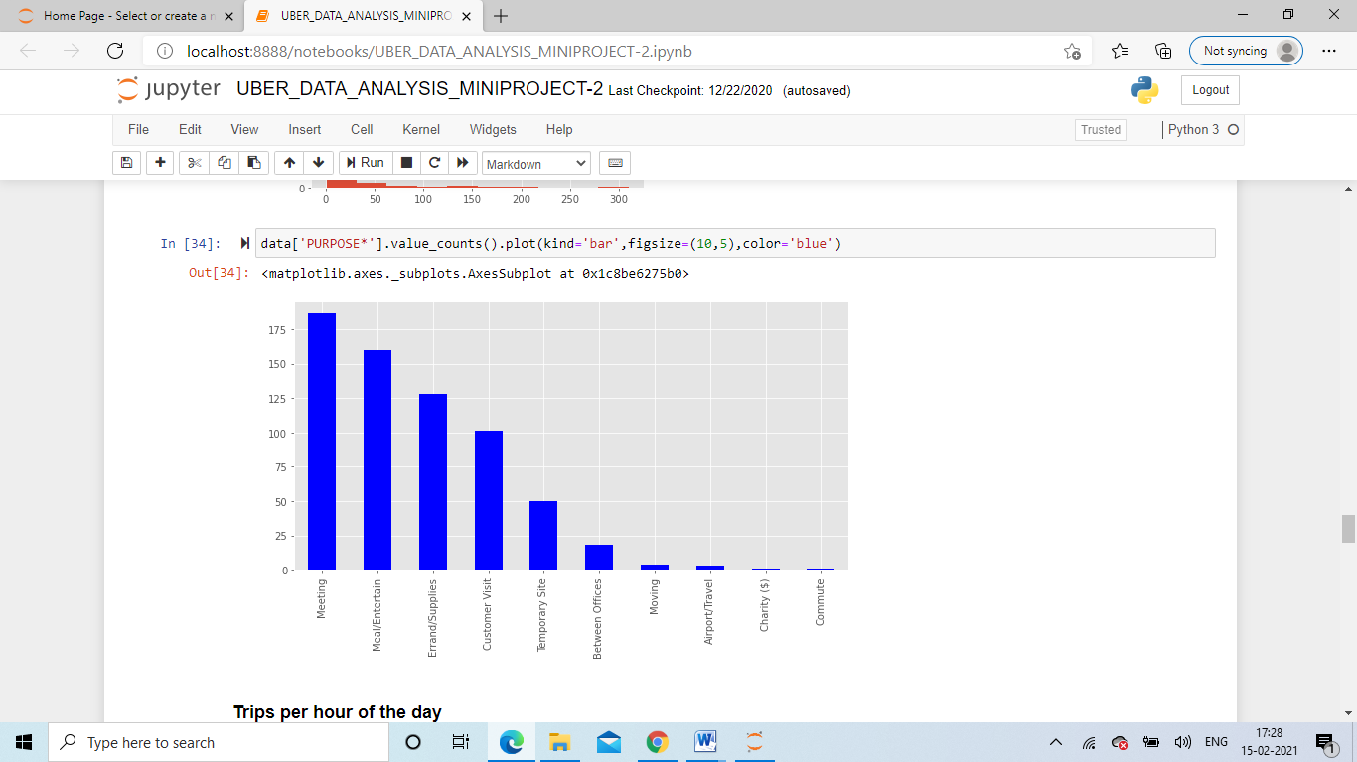
Fig.7.14 Trips per hour analysis

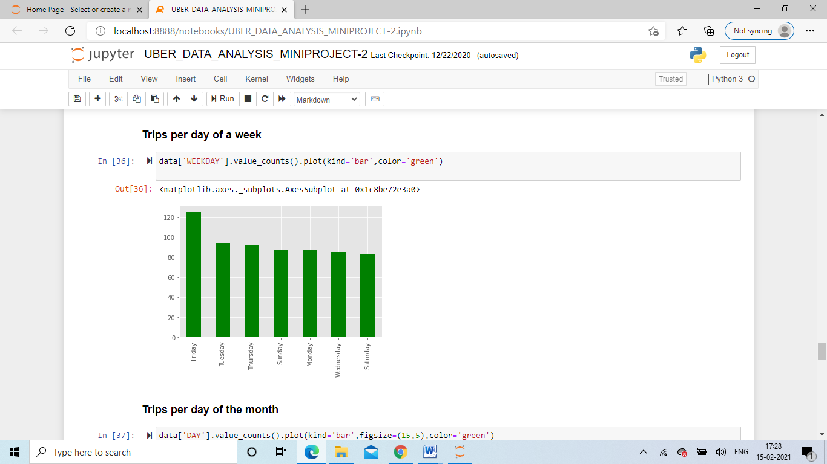
Fig.7.15 & Fig.7.16 Trips per day of week & month analysis

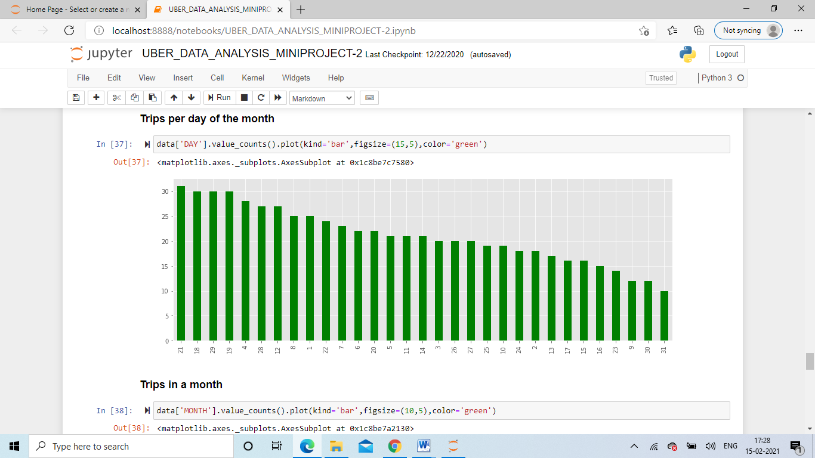
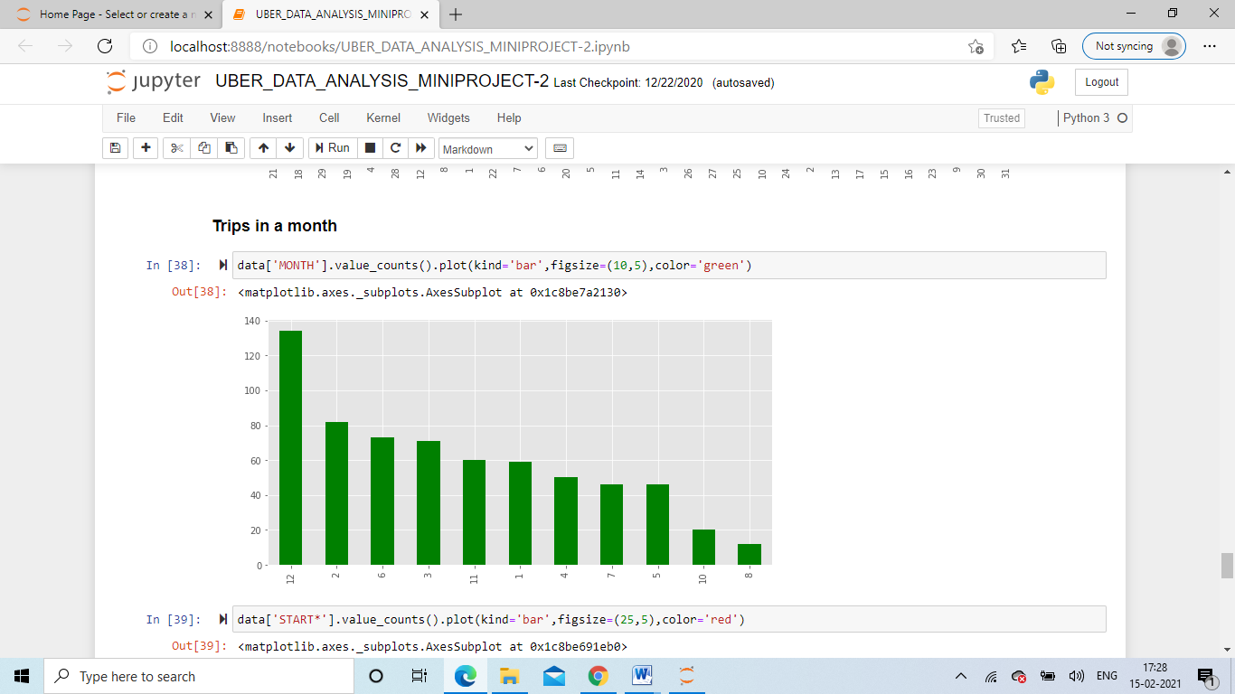
Fig.7.17 & Fig.7.18 Trips in month & Count analysis

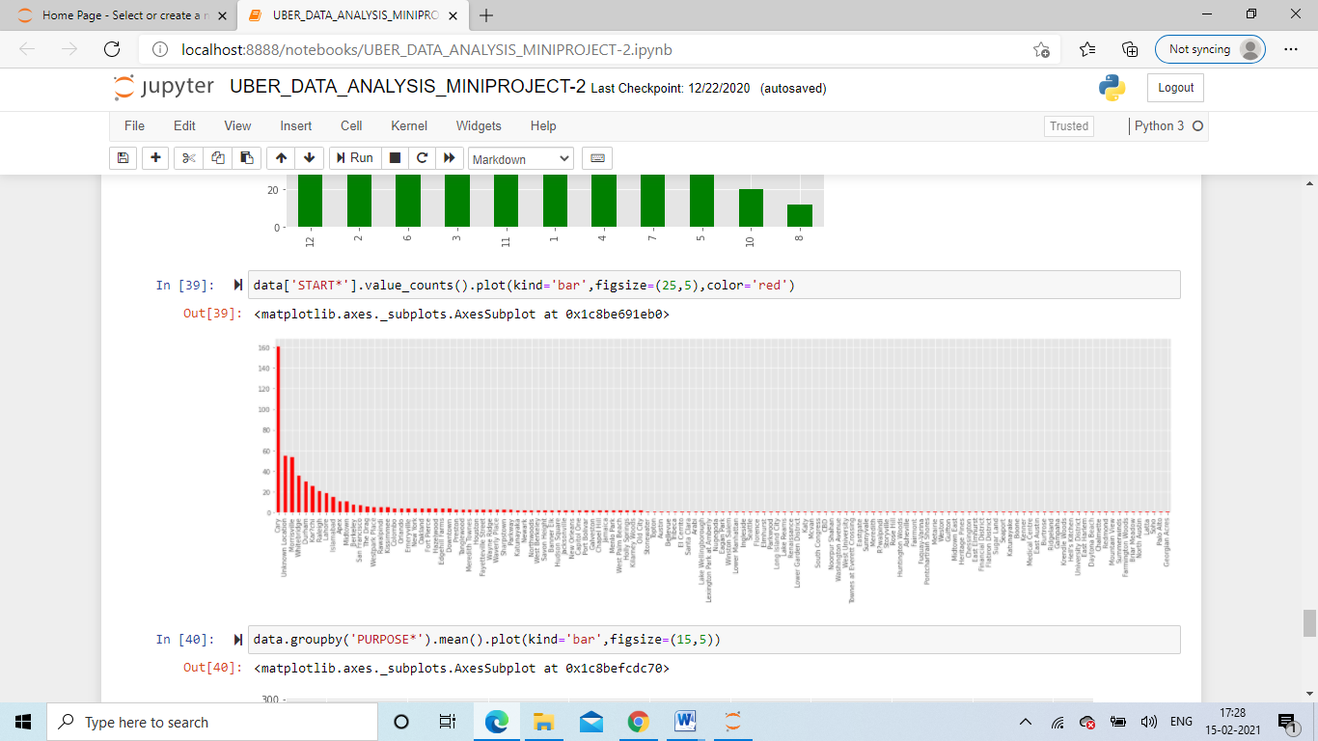
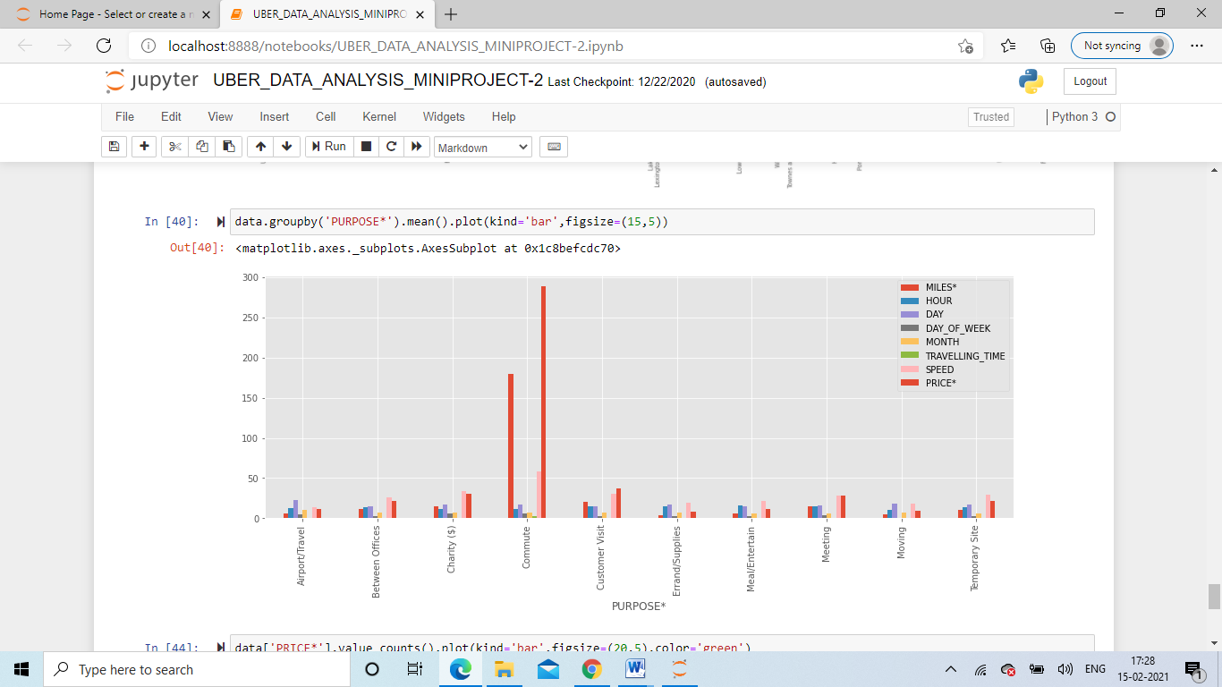
Fig.7.19 & Fig.7.20 All Purpose & Price analysis

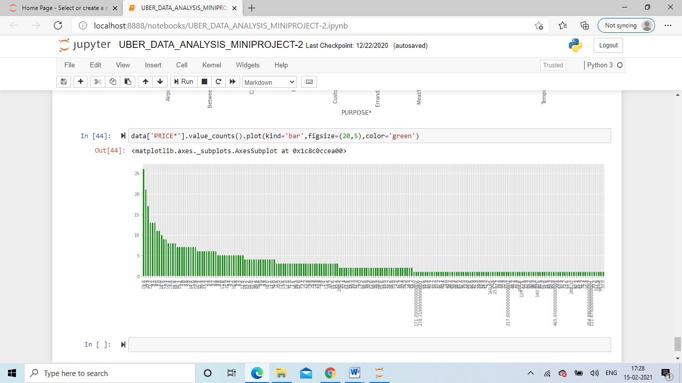

REFERENCES
1. https://www.codespeedy.com/analyse-uber-data-in-python-using-machine-learning/.
2. http://freeieeeprojectschennai.co.in/analysing-uber-data-and-selecting-popular-destination- using-big-data.php.
3. https://www.kaggle.com/theoddwaffle/uber-data-analysis.

